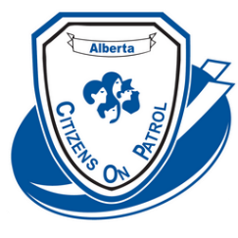ACOPA ANNUAL GENERAL MEETING & WORKSHOP

October 28, 29, 30 2022

HOSTED BY Strathcona County Citizens On Patrol Society

To be held at the Sherwood Park Agora

401 Festival Lane, Sherwood Park, Alberta T8A 5P7

**REGISTRATION FORM**

Delegate Name____________________________________________________________

Telephone #______________________________E-Mail____________________________

ACOPA ID # _______ C.O.P. group _____________________________________________

Are you a Liaison Officer? _____ For which C.O.P. group? __________________________

Attending Administrator training Friday 15:00 - 17:00 Yes ________No_______

(Must bring your computer)

Attending Friday afternoon Training 14:00 - 17:00 Yes________ No­­­­­­­­­­­­­­­­­­­­­­_______

(For first time attendees)

Attending Friday Supper Yes ________ No_______

Attending Saturday meals Breakfast _____Lunch _____ Supper ____

Attending Sunday Higher Level Training 9:00 – 11:00 Yes _______ No _______

**Registration fee $75**

Extra Saturday supper tickets $30.00. Circle # of extra Tickets needed 1 2 3

Please include payment with your registration.

**Please register by October 1st or earlier.** Receipts will be available at the registration desk.

Send registration form and payment by e-transfer to [registration@acopa.ca](mailto:registration@acopa.ca)

**OR**

Send a cheque payable to Alberta Citizens On Patrol Association (ACOPA) to:

Alberta Citizens On Patrol Association

c/o Garth Kohlsmith

#204 – 9928 – 105 Street

Westlock, Alberta T7P 1S7