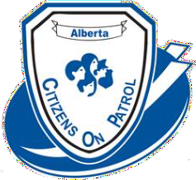
ACOPA Workshop & Annual General Meeting

September 13, 14 and 15 2024
Hosted by Red Deer Citizens On Patrol Society
Location: Baymont Hotel 4311 49th Avenue Red Deer
REGISTRATION FORM

Delegate Name

Telephone # E-Mail

ACOPA ID # C.O.P. group:

Are you a Liaison Officer? For which C.O.P. group? _____________________

Please check off what applies:

Friday training (first time) Yes ____No ____
Administrator training/review Yes ____No ____
Friday Supper Yes ____No ____
Saturday meals Breakfast ____Lunch ____Supper ____
Sunday training (advanced) Yes ____No ____

Will you be staying at the Baymont hotel? Yes ____No ____

Extra Saturday supper tickets $30.00. Circle # of extra Tickets needed 1 2

Registration fee $75 Due by August 30.

Please include payment with your registration. Receipts will be available at registration.

Email the registration form to registration@acopa.ca and send an e-transfer for the registration fee to registration@acopa.ca OR

Send the registration form and cheque payable to Alberta Citizens On Patrol Association
c/o Garth Kohlsmith
#204 – 9928 – 105 Street
Westlock, Alberta T7P 1S7

