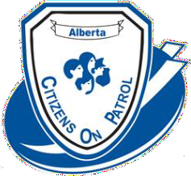
ACOPA Workshop & Annual General Meeting

October 13, 14 and 15 2023
Hosted by Lloydminster Citizens On Patrol Society
Lloydminster Agricultural Exhibition Association
5521 49 Ave Lloydminster Saskatchewan S9V 0Y7

REGISTRATION FORM

Delegate Name

Telephone # E-Mail

ACOPA ID # C.O.P. group:

Are you a Liaison Officer? For which C.O.P. group? _____________________
Attending Friday training (first time) |  | Yes No
Attending Friday | Supper | Yes No
Attending Saturday Breakfast Lunch Supper____

Attending Sunday training (advanced) Yes __ No ____

Registration fee $75 Due by September 22nd.

Extra Saturday supper tickets $30.00. Circle # of extra Tickets needed 1 2 3

Please include payment with your registration by September 22 or earlier. Receipts will be available at registration.
Email the registration form to registration@acopa.ca and do an e-transfer for the registration fee to registration@acopa.ca

OR

Send the registration form and cheque payable to Alberta Citizens On Patrol Association
c/o Garth Kohlsmith
#204 – 9928 – 105 Street
Westlock, Alberta T7P 1S7

